**Touch Sensor**

**TouchSensor.x3d**

Cyan Cone - cursor over the cyan Cone begins movement (translation) of pink Box from the background and past the camera out of view (unless the user turn their head).

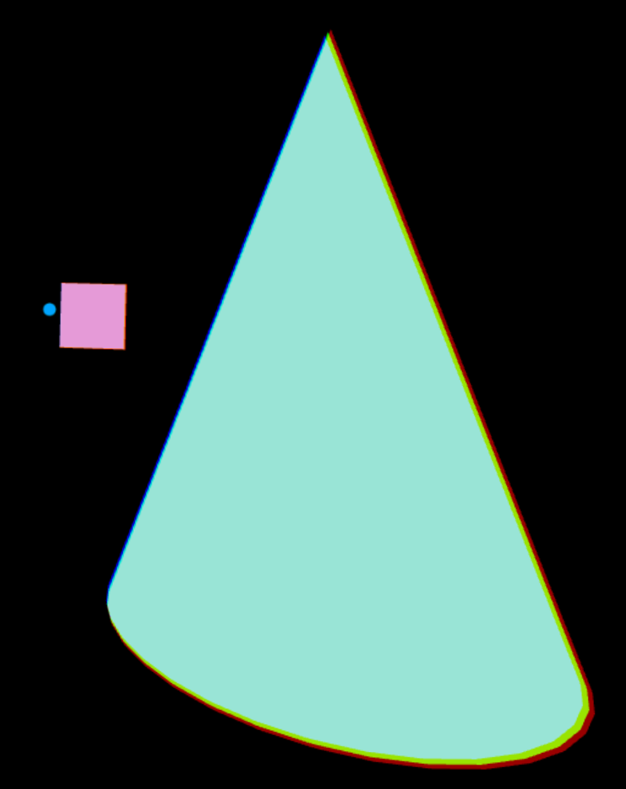 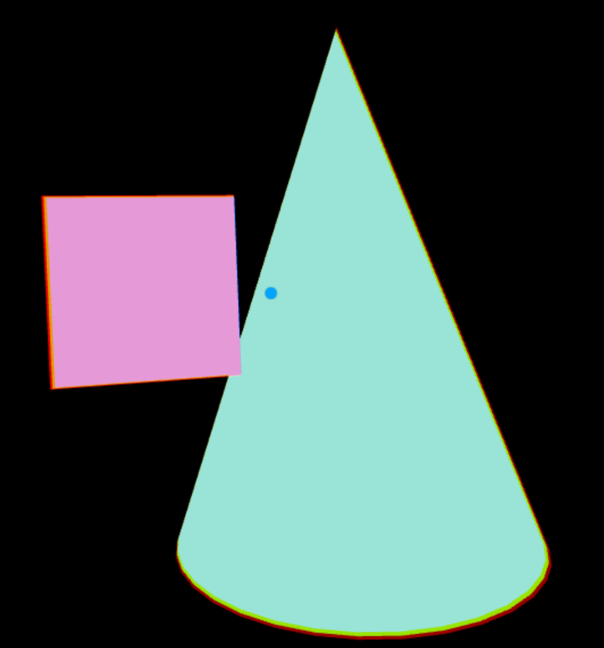

**TouchSensor1.x3d**

Blue Cone - cursor over the blue Cone begins rotation of yellow Cylinder and green Cone and movement (translation) of pink Box

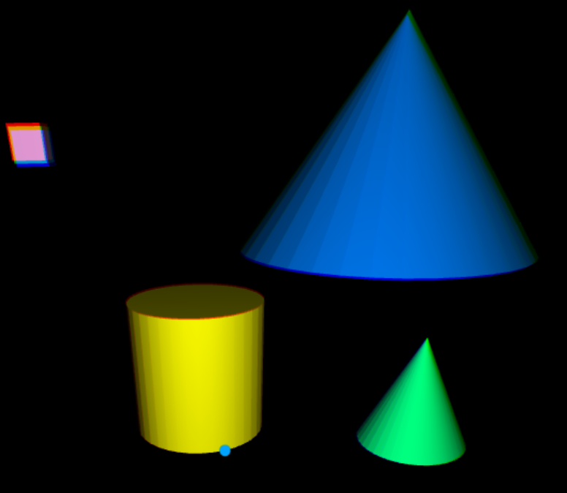

Placing the cursor over the blue Cone moves the pink Box toward the camera and then beyond the camera, and rotates the yellow Cylinder, both in 8 seconds. It also rotates the green Cone over 16 seconds.

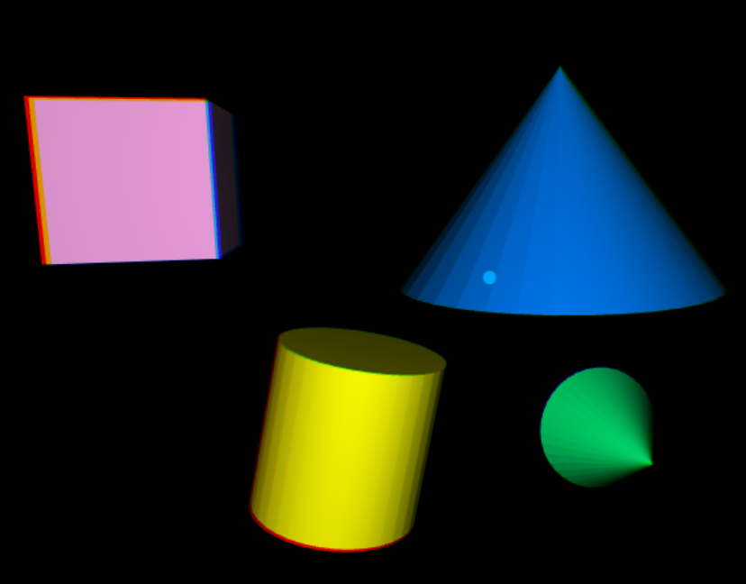

**TouchSensor2.x3d**

Similar to TouchSensor1.x3d, but adds a Red cone – perpetual animation up/down/up with rotation

Blue Cone - cursor over the blue Cone begins rotation of yellow Cylinder and green Cone and movement (translation) of pink Box

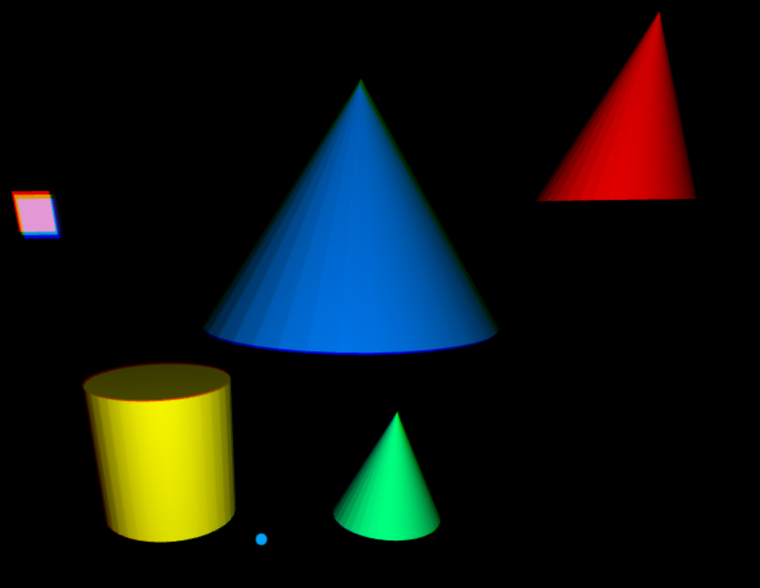

Placing the cursor over the blue Cone moves the pink Box to the camera and then away, rotates the yellow Cylinder, both in 8 seconds. And rotates the green Cone over 16 seconds. The red Cone continues to move up and down.

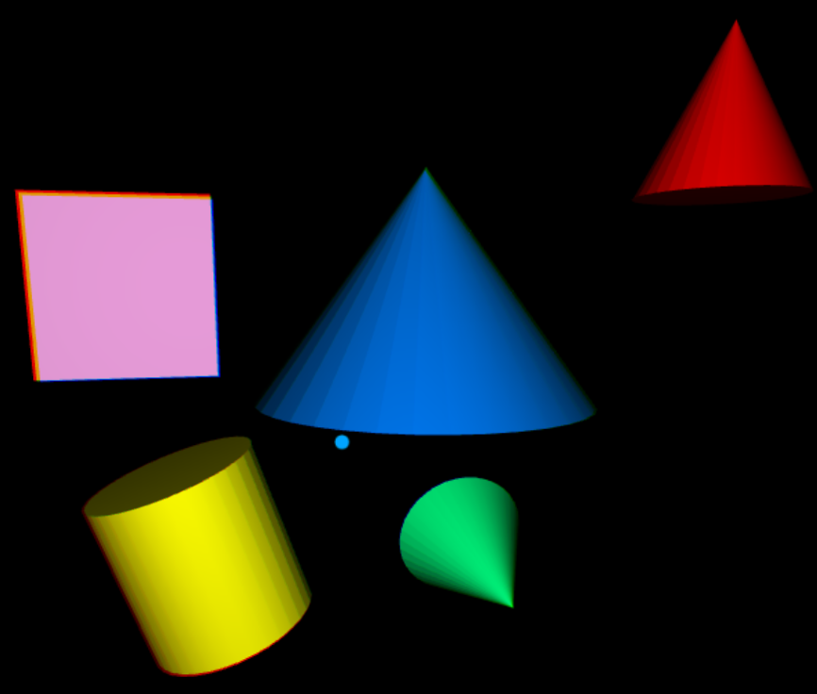

**TouchSensor3.x3d**

Similar to TouchSensor2.x3d, but now the Red cone also rotates and a plane textured with “North/East/West/South” perpetually scales small to big, then back to small again.

These demonstrations check to make sure no unintended interactivity occurs.

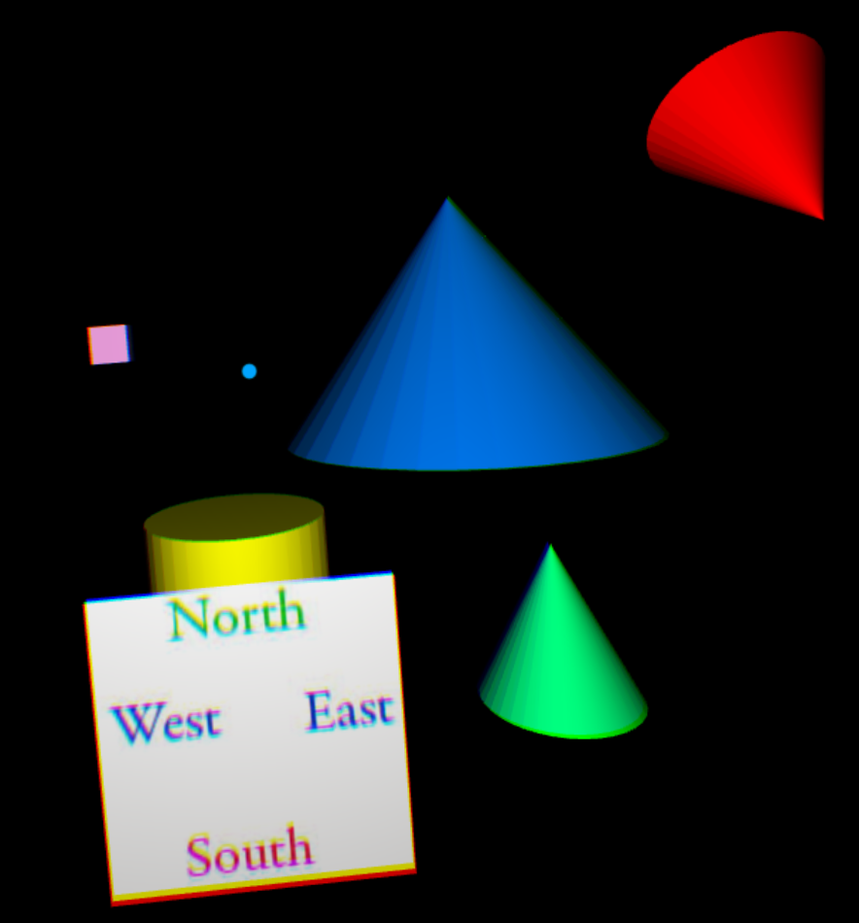

Placing the cursor over the blue Cone moves the pink Box toward the camera and then away from it, plus rotates the yellow Cylinder, both in 8 seconds. It also rotates the green Cone over 16 seconds.

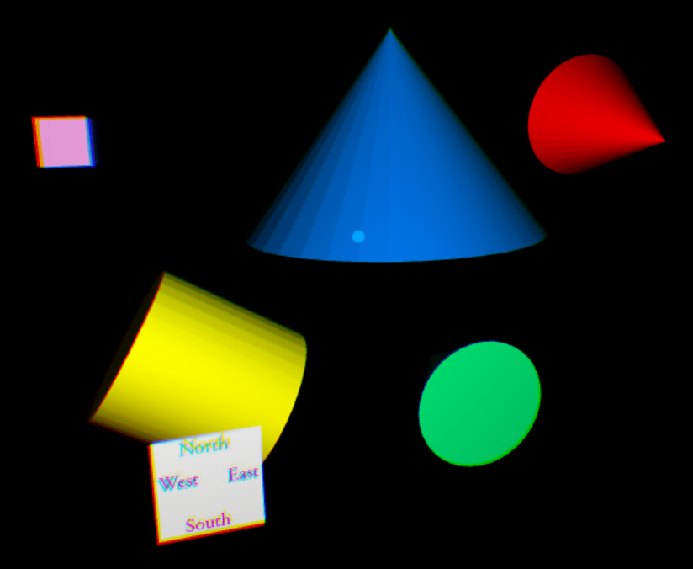 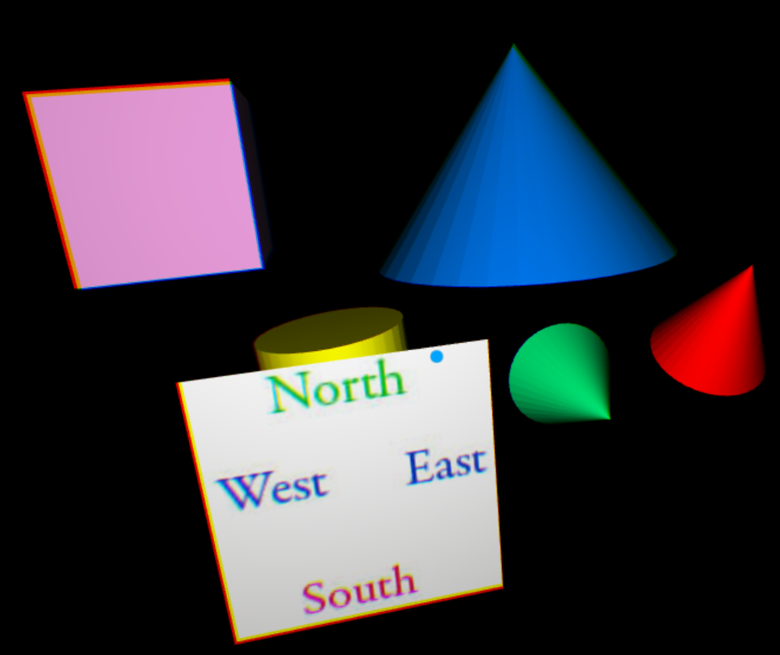

**TouchSensor4.x3d**

Red cone – perpetual animation moving left-to-right-to-left with rotation

Green cones – cursor over the green Cone begins orange Cylinder animation (translation).

Blue cones – cursor over the blue Cone then clicking GearVR’s Touchpad begins animation of theyellow and orange Cylinders.

Gray cone in center does nothing.

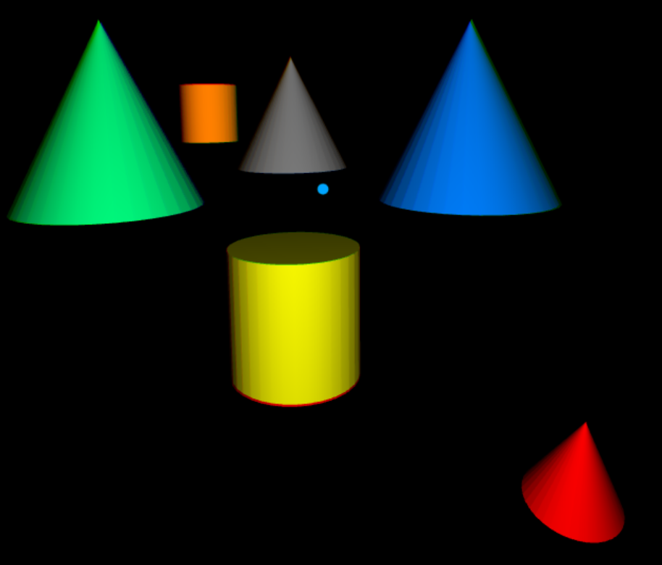

Placing the cursor over the green Cone begins the movement (translation) of the orange Cylinder.

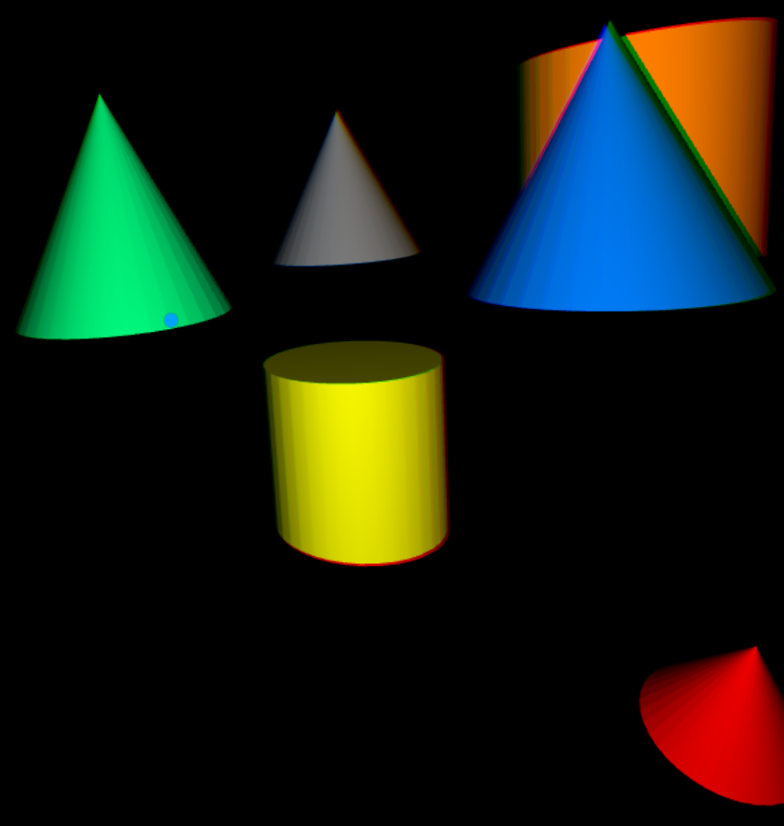

Placing the cursor over the blue Cone and clicking on GearVR’s Touchpad animates both the orange (movement) and yellow (rotation) Cylinders.

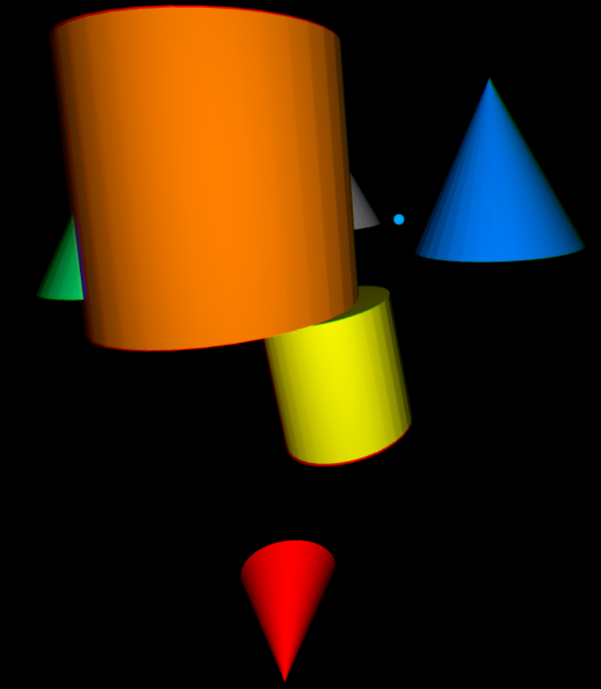

**TouchSensor5.x3d**

Similar to TouchSensor4, except now green and blue Cones have child objects that can also initiate animations.

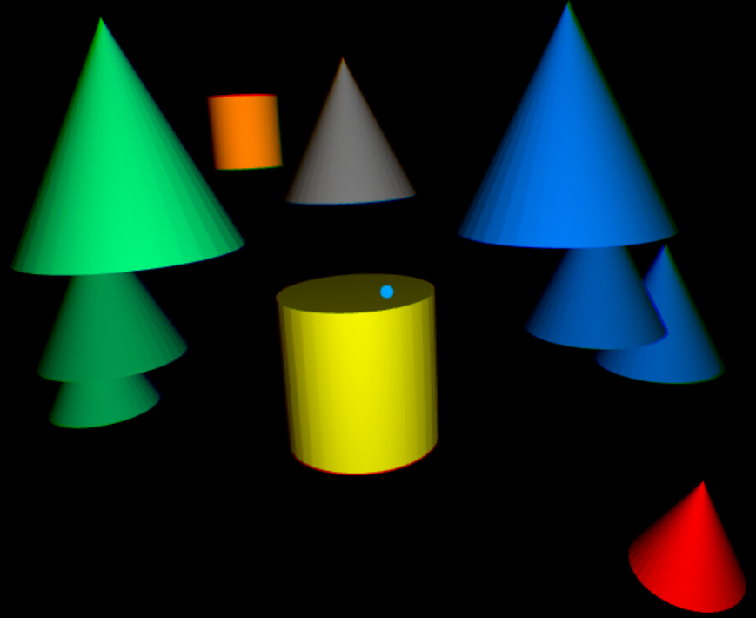

Cursor over any green Cone animates orange Cylinder

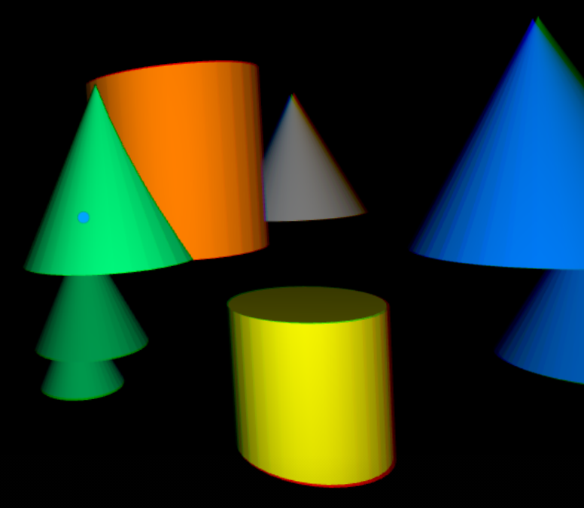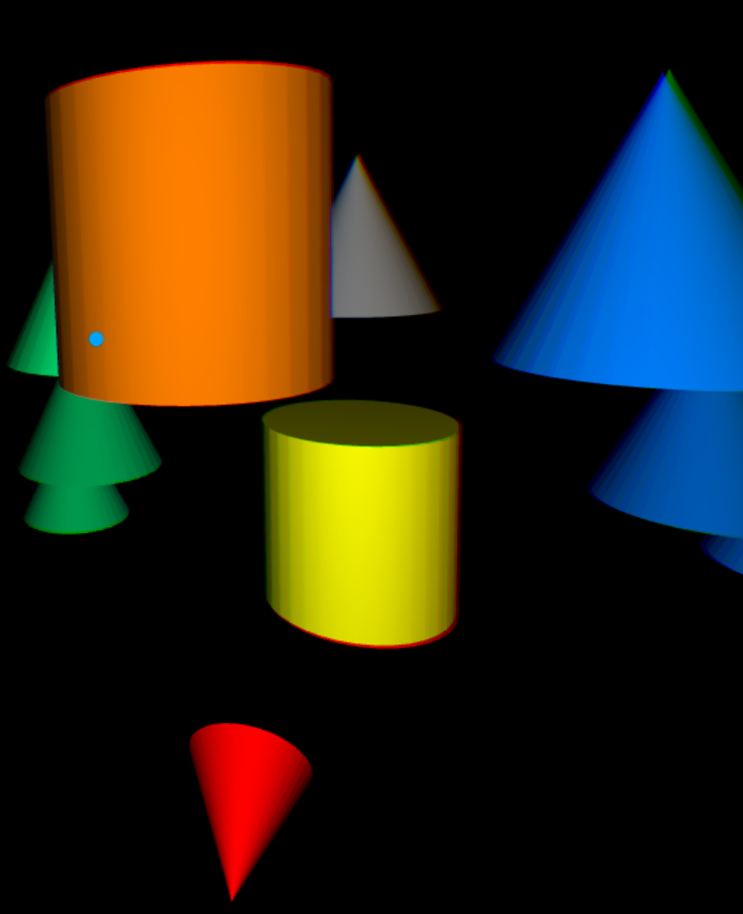

Cursor over any blue Cone and clicking on the GearVR Touchpad moves the orange Cylinder (same as with the green Cones) plus rotates the yellow Cylinder.

